**Minutes of Meeting**

**IGU PGCA**

25-28 September 2012

Sapporo Renaissance Hotel

# Introduction

The first PGCA meeting in the triennium 2012-2015 took place at the Renaissance Hotel in Sapporo, 25-28 September 2012, jointly with WOC1.

A total of 47 IGU delegates attended this meeting, of which 31 from PGCA.

# Opening

Mr. Satoshi Yoshida, Chairman of PGC A, introduced the invited guests and authorities to all delegates. He presented Hokkaido as a new frontier for economic development in Japan, with significant growth expected in the production of food and in the consumption of natural gas, for example.

All emissions produced by the meeting were calculated and completely compensated with the plantation of trees at the Carbon Legacy Forest developed during the G8 Summit of Hokkaido in 2008 (<http://www.sapporo-convention.net/environment/index.html>). A participant from Rio de Janeiro, on the opposite side of the globe, was estimated to produce nearly 3.9 tons of carbon dioxide.

Mr. Denis Dinelli, Chairman of WOC 1, thanked the participants and desired them a fruitful meeting, with meaningful results for their organizations as well.

# News from the Coordination Committee

The Chairman of the Coordination Committee, Mr. Georges Liens, presented the theme for the current triennium, “Growing together towards a friendly planet”, and the four pillars that support it: (1) Advocacy for the development of natural gas as a foundation fuel for Sustainable Development, (2) promotion of an accurate combination with renewables and electricity, (3) improvement in the availability of natural gas in new areas and developing countries and (4) attraction and retention of human resources (Figure 1).



Figure1. The IGU strategic vision for the 2012-2015 triennium (Liens, 2012).

In the sequence he introduced the IGU Committees and Task Forces for the current triennium, and a list of themes that have been previously arranged for them. As an example, PGC B will continue to coordinate the formulation of perspectives for supply, demand and prices, while PGC C will analyze the use of gas to promote sustainable development in emerging countries, and PGC E will study an “i-gas industry” whose details seem to be still under elaboration.

A number of transversalities or interfaces have been identified between the committees. This would be important to secure the development of consistent and congruent messages in all committees.

As of 11 September, 646 nominations to the IGU Committees have been received from 41 countries, of which 45 to PGCA (Table 2). Some IGU members are still elaborating their lists to the Coordination Committee.

Table2.Number of nominees



On top of the regular committee reports, the Coordination Committee has decided to compile a few additional reports, as indicated in Table 3.All materials must be ready to be submitted to the CC by March 2015.

Table3. Special reports to be elaborated in the triennium 2012-2015



The call for papers for WGC 2015 is supposed to be opened by 1st February 2014.

Table 4.Deadlines for contributions to WGC 2015.



Mr. Yves Tournié, Secretary of the Coordination Committee, urged all committee secretaries to update their IGU websites. A large number of members do not have a budget to travel abroad, relying on the IGU website to follow the progress of the committees as a consequence.

He introduced the attendees to the French WGC website, which is available at [www.wgc2015.com](http://www.wgc2015.com). Real time information about the gas industry and the French triennium can be found there, and also a link to the collaborative platform that was recently developed by the French presidency at[http://ccmembers.wgc2015.org](http://ccmembers.wgc2015.org/)(or <https://wgc-2015.users.dimelo.com>).

This is a space where committee members can share ideas, comments and documents, “tweeting” to each other as in a social network. It contains samples of the work in progress, information about future meetings and other useful information. Presentations and reports of up to 20 MB can be uploaded and downloaded from there.

# Shale gas

In October 2011, in a joint session with the IEA in Paris, it was decided that the IGU should take a position on shale gas.

This effort was led by the current Vice-Chairman of the Coordination Committee, Mr. Mel Ydreos, and the results achieved were published during the last WGC (Figure 2).

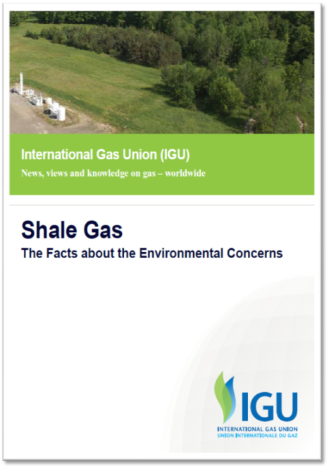

Figure 2.Apparently criticized by the Sierra Club, this document was largely accepted.

In his presentation in Sapporo, Mr. Ydreos criticized the polarized visions prevailing among industry officials and environmentalists. He detected a need to reshape the conversation, calling the attention of the audience to the fact that the focus of the discussion is now moving from the subsurface to above the ground issues such as water usage, methane leakage from natural gas infrastructure and truck traffic.

Media coverage of shale gas issues has intensified, and a number of jurisdictions have imposed restrictions, such as Quebec, Newfoundland, France and South Africa, but some quality research is now emerging that could produce a strong positive impact, and a similar effect could come from the establishment of best practices by the industry, where WOC 1 could have a key role. As an example, drilling time has been reduced to half of what it used to be just a few years ago, reuse of water is significantly up, and micro seismic technologies have evolved significantly.

A recent survey conducted by the Canadian Gas Association located unconventional gas below nuclear energy in popularity, while conventional gas was considered to be one of the best options, a paradoxical result to a certain extent (Figure 3).

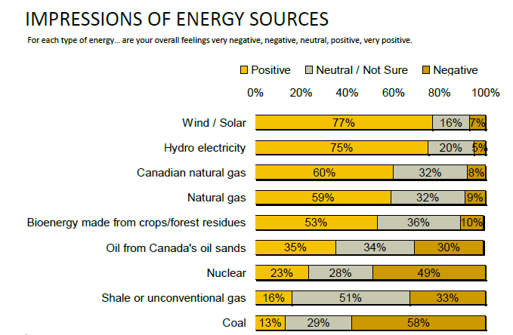

Figure 3. Research conducted by the Canadian Gas Association (Ydreos, 2012).

Rig activity recently moved to wet plays because of the large differences between gas and liquid prices, but now even the latter are suppressed, and rigs are moving again to unconventional oil plays. The industry would need about US$ 4-5 per MMBtu, so a tendency of decline would be expected at the current price levels.

The World Bank is currently performing a full life cycle analysis of the Polish shale gas whose results are much expected.

# Gas advocacy

Mr. Georges Liens represented the Chairman of TF 2, Mr. Michele Pizzolato. This task force is supposed to advocate in favor of natural gas as a clean, affordable, reliable, efficient and secure fuel.

Clear messages are much needed here, as the development of incentives for partnership with renewables is not a straight forward activity, and significant investments would be needed to promote either international carbon trading or CCS.

# Gas transmission

Mr. Peter TÓth, Study Group Leader in WOC 3, presented the activities of this important Committee, and explored the transversalities of his group with PGC A. Points of interest include CCS, life cycle assessment, and environmental aspects of unconventional gas, where a small interface with WOC 1 could exist (impact of new gas sources in the transmission systems around the world).

# PGC A and the IGU strategic vision

The Chairman of PGC A, Mr. Satoshi Yoshida, described the relationship between the themes developed by his committee and the pillars of the current IGU strategic vision, i.e., sustainable development, combination with renewables and electricity, availability of gas and human resources.

# WOC 1 and the IGU strategic vision

Mr. Denis Dinelli, Chairman of WOC 1, emphasized the role of WOC 1 in the red pillar of the French strategic vision (natural gas available everywhere). WOC 1 is expected to produce a significant contribution in the green pillar as well (natural gas for a sustainable development), as one of its study groups is supposed to propose best practices for flare reduction.

# PGCA sessions

The Chairman of PGCA, Mr. Satoshi Yoshida, introduced 4 study groups and the group leaders proposed for the current triennium, and showed possible transversal issues and contact groups (persons).

4 study group leaders made presentation about their work plan and members decided which study group to join in.

## SG1: Carbon Capture and Storage, Leader: Hiromichi KAMEYAMA, Tokyo Gas (Japan)

CCS has the potential to play an important role amongst a broad portfolio of options, including energy efficiency or renewables, for addressing energy security and tackling climate change. According to some energy scenarios, CCS can contribute even to 20% of the necessary GHG emissions reductions for halving emissions by 2050. CCS technology could become a threat to the gas industry, giving an added value on other fuels like coal, but the gas industry has the potential to lead in this CCS technology. R&D efforts need a long lead time and careful discussions are needed on drawing the technology roadmap.

This study group, collaborating with WOC1 on geological, WOC2 on storage, WOC3 on CO2 pipeline issues, eyeing to make the technology “Roadmap”, showing different aspects and progresses of the ongoing projects, suggests preferred direction for future CCS development in the sustainable gas industry in this triennium.

The roles of CCS in a sustainable gas industry are:

1) Cut CO2-emissions from gas industry itself and natural gas consumers.

2) Help formation of a low carbon energy portfolio by working other energy sources.

3) Expanding the business of the gas industry by creating new value, using CCS technology.

In Sapporo meeting, members agreed on the work plan proposal of this triennium (6members from Algeria, France, Iran, Japan, Malaysia attended the meeting.).

1st year : Checking ongoing and planned CCS projects and discussion about the “Work contents" 1.Technology(Link with renewable energy, Specific CO2 capture technology for gas turbines), 2.Feasibility, 3,Legal frame, 4.Public acceptance, etc.---

2nd year : Discussing about the " Critical points for the development of CCS for gas” and will make CCS road map based on it.

3rd year : Finalizing the report and the presentation.

## SG2 Natural Gas and Renewable Gas, Leader: Elbert Huijzer, Liander (Netherlands)

In order to lower the carbon emissions of energy supply systems with lower social cost, we need to make maximum use of the existing energy infrastructure in combination with technologies for various aspects of the overall system to optimize, renovate and modify. Wide-ranging R&D efforts are underway to increase the efficiency, flexibility, safety, reliability and quality of “Integrated Grid”, the electricity and gas systems and networks, to facilitate the transition to a more sustainable energy system.

For gas networks, it is important to demonstrate more intelligent and efficient processes and systems for gas transport and distribution, including the effective integration of renewable energy sources and the use of biogas in the existing networks.

This Study Group made “Renewable gases” report last triennium, illustrating the need for operators to develop smart gas grids and be involved in gas quality monitoring as well as in setting up specifications and standards to make the gas grid as the most energy efficient and environmentally friendly way to transmit renewable gases. In this triennium, based on Country Studies, further analysis on economic and social aspects will be conducted and the group steps into more detail with an objective approach about financing, regulations, local effects on economics or ecology, explaining why renewable gases are a good match with other renewables and with natural gas.

In Sapporo meeting, 5 members were present and members will prepare country reports for next meeting and necessary data or information will be collected also by personal contacts or a questionnaire. No participation from developing countries and it is getting difficult to fulfill the task on off-grid biogas projects. (Issue of “integrated grid” will be vision document on “integrated energy services”, collaborating with PGCF.)

## SG3 LCA study of the Natural Gas Chain, Leader: Anne-Prieur-Vernat, GDF-SUEZ (France)

The superior environmental quality of natural gas combustion is undisputed due to its chemical composition but some have alleged that it is not so environmentally benign due to substantial leaks upstream and in the supply chain of methane, which has a high global warming potential.

Several LCA studies were published by academic or consulting bodies but no homogeneous work was published by the gas industry and increasing number of stakeholders expect to gas industry to conduct LCA studies to show its environmental competitiveness.

Based on IGU study performed in 2006 by CE Delft, and Marcogaz study of the European natural gas chain, using ISO standards, this study group sets up an international databases for LCA of the natural gas chain within IGU and conducts multi-criteria assessment on Global Warming, Non renewable energy depletion, Impacts linked to atmospheric pollution, and Water Footprint. (Collaborate with PGCD on “LNG/LCA” and WOC3 on transmission issues.)

This will help the gas industry for continuous improvement of the environmental performance while providing environmental data to influence the choice of energy by final customer, advocating for the development of natural gas as a practical solution for sustainable development.

In Sapporo meeting, 7 members in the list (from Algeria, Belgium, France, Iran, Japan, Korea) were present and Work plan agreed until WGC 2015. Scope and indicators to be assessed have been defined and the 1st draft of questionnaire for environmental data collection to be circulated by the end of October within SG3 members.

## SG4 Environmental Aspects of Unconventional Gas

Golden Age of natural gas scenario by IEA assumes prices are $3 to $7 per mcf due to ample supply, primary from unconventional resources in many areas of the world. But, producing unconventional gas is generally imposing a larger environmental footprint than conventional gas development and it is getting controversial. Some governments are hesitant, or even actively opposed, responding to public concerns that production might involve unacceptable environmental and social damage.

Based on IGU Report “Shale Gas: The Facts about the Environmental Concerns”, learning from the discussions and experiences in North America, looking regional developments also, collecting those environmental arguments exhaustively, this study group categorize and analyze their backgrounds and identify management and technology best practices to solve them.(Collaborate with WOC1 on the latest exploration and production technologies, WOC3 on “Public Acceptance & New Technologies” and “Middle Infrastructure” issues.)

In Sapporo meeting, 6 members and 1 observer from Exxon Mobil were present and agreed on the proposed work plan of this triennium. Collaborating with WOC1 on the latest exploration and production technologies,WOC3 on public perception and middle infrastructure issues, members are to share basic information (IGU reports, IEA reports, and other “must read” materials) and leader is to list up and categorize all the arguments and discussion points until the next meeting with some analysis on them.

## Others

Meetings are scheduled as indicated in Table 5, with an average anticipation of six weeks relatively to the corresponding Executive/Coordination Committee. The second meeting of the group is already confirmed, but venues thereafter are under discussion.

Table 5. PGCA meetings in the 2012-2015 triennium.

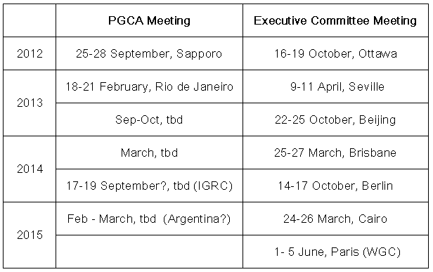

Deliverables expected include progress reports to the Coordination Committee and IGU Magazine (prepared by the Secretary of PGCA every six months), a triennial report (first complete draft should be ready by September 2014), articles to the IGU Magazine (two per study group during the current triennium), and support activities to for other Committees or Task Forces.

At the WGC 2015, PGCA is supposed to organize two or three committee sessions (oral panels with presentations performed mostly by the members of the study groups), one expert forum (presentations selected mostly from the call for papers), one strategic panel, and one Interactive Expert Showcase.

PGCA is also to screen submissions received for IGU Social Gas Award: Encouraging Gas Efficient Behavior” and select 3 finalists.

# The role of gas in an ideal energy mix: A UK perspective

Mr. Richard Oppenheim, diplomat in charge of the Department of Energy & Climate change at the British Embassy in Japan, described the three priorities of the UK energy policy: Climate change, security of supply and affordability.

His department was created in 2008 to ensure a coherent strategy on energy and climate change. Ever since, four carbon budgets have been developed with reduction targets of 25% by 2009, 34% by 2020, 50% by 2027 and 80% by 2050.

Gas has a key role there, as in 2010 nearly 46% of all electricity was produced from gas, and 71% of the heating was also produced from gas. Gas accounts for about 37% of the UK primary energy, and has a large influence in the formation of electricity prices. This is expected to continue as coal will be displaced by new nuclear facilities and wind energy, according to the data presented in Figure 4.

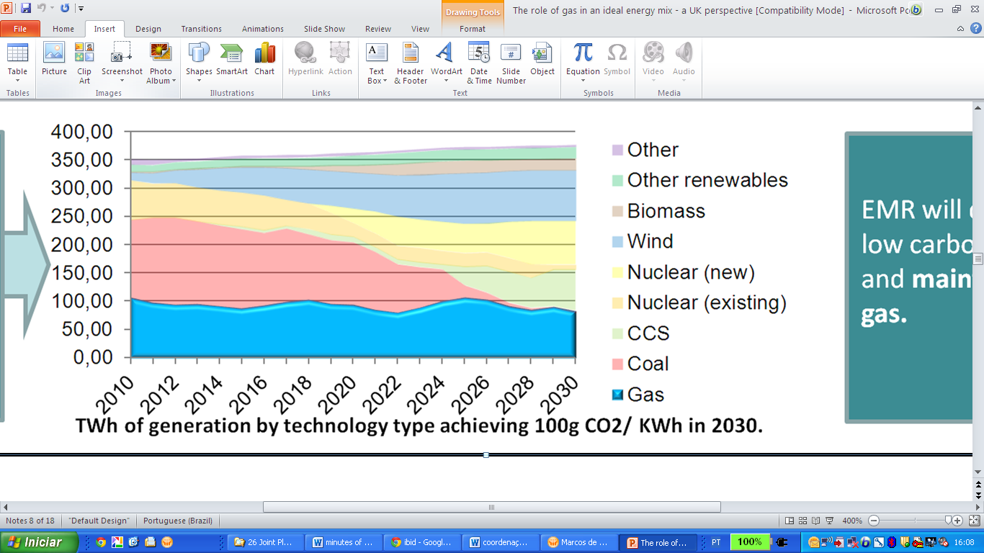

Figure 4.TWh by modal to achieve 100g CO2/KWh in 2030 (Oppenheim, 2012).

Imports will increase as the indigenous production in their continental shelf declines, but international supplies are abundant and their transportation is also reliable.

He called the attention of the audience to the fact that climate change is more of an economic issue than one may think, as the potential economic damage caused by inertia is far higher than the cost of remediation.

# Ishikari LNG terminal

In the last day of the meeting, the delegates of WOC 1 and PGC A had the opportunity to visit this brand new LNG terminal, where they received first hand information from Hokkaido Gas officials and technicians (Figure 5).

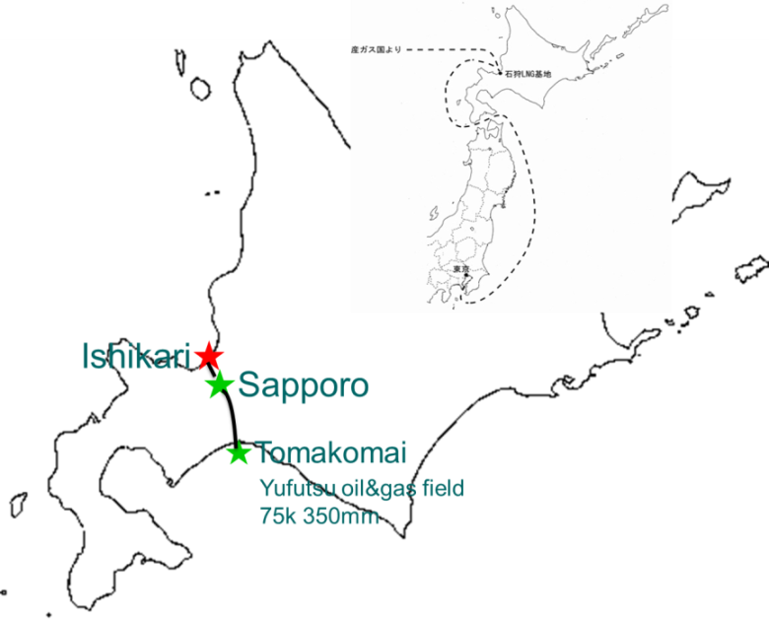

Figure 5 Location of the Ishikari LNG terminal in Hokkaido (Yoshida, 2012).

This terminal was developed because the local production in the Yufutsu field has declined. It has only one storage tank, but it is one the largest aboveground in the country, with a capacity of 180.000 m3.

The facilities will be commissioned in October, and about 10% of the production will be transported by trucks to large consumers. Coastal shipping is also relevant to the business, but most of the production will be piped to Sapporo after re-gasification.

# Second joint meeting of PGC A and WOC 1 in Rio de Janeiro

Dr. Marcos Sugaya, Secretary of WOC 1, presented the agenda for the second meeting of the group, which will take place at the Windsor Atlantica Hotel in Copacabana, 18-21 February 2013.

Delegates will meet with the highest gas authorities in the country, and will have the opportunity to debate on the role of gas in the development of a sustainable energy future in a special workshop organized at the new R&D facilities of Petrobras (Figure 6).

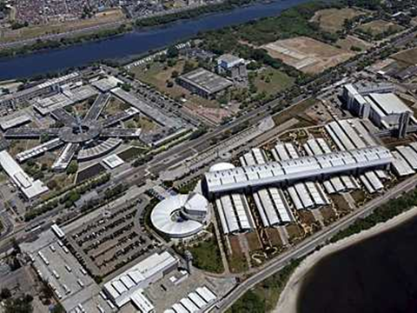

Figure 6.Petrobras’ R&D Centre Cenpes was recently revamped.

In addition to that, they will visit the Guanabara Bay LNG Terminal, which was recently nominated as one of the most interesting infrastructure projects by KPMG and the Journal of Infrastructure.